**The Battel Of Neighborhoods**

**[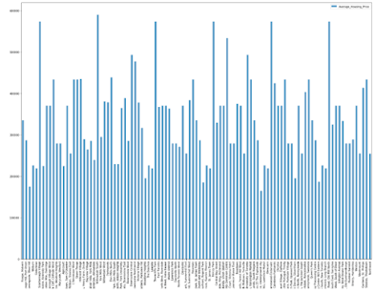](https://lh3.googleusercontent.com/-sQRsLS_wRiM/YCDc75vHzbI/AAAAAAAALnk/_zi82uqD8LwNFRF9fi4Hi-UEA66NP27UwCLcBGAsYHQ/image.png)**

**Introduction:**

The purpose of this Capstone Project is to help people in exploring better facilities around their neighborhood. It will help people making smart and efficient decision on selecting great neighborhood out of numbers of other neighborhoods in Scarborough

Lot of people migrate to Canada with there family in search of Better Life standered, and because of that most of the time People waste their time/money/energy in search of better Neighborhoods with good housing prices and reputated schools for their children ease of accessing to Cafe, School, Super market, medical shops, grocery shops, mall, theatre, hospital, like minded people, etc.

This Project aim to create an model of features for a people migrating to Scarborough in search a best neighborhood as a comparative analysis between neighborhoods. The features include median housing price and better school according to ratings, crime rates of that particular area, road connectivity, weather conditions, good management for emergency, water resources both freash and waste water and excrement conveyed in sewers and recreational facilities.

It will help people to get awareness of the area and neighborhood before moving to a new city, state, country or place for their work or to start a new fresh life.

**Data Section:**

Data: <https://en.wikipedia.org/wiki/List_of_postal_codes_of_Canada:_M>

Will use Scarborough dataset which we scrapped from wikipedia on Week 3. Dataset consisting of latitude and longitude, zip codes

[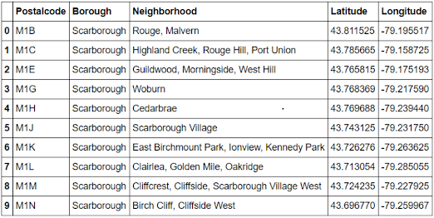](https://lh3.googleusercontent.com/-kqOd4yUWSg0/YCDeEa8HupI/AAAAAAAALnw/rjw5E824xXIS1fHCBmVhUqpEZm5Ty7r6QCLcBGAsYHQ/image.png)

Using credentials of Foursquare API features of near-by places of the neighborhoods will be fetched.

* places per neighborhood parameter: 100
* radius parameter: 500

Foursquare API:

foursquare api is used for gathering required info for the Scarborough, especially foursquare places API which provides the ability to perform location search, location sharing and details about a business.

The data retrieved from Foursquare contained information of venues within a specified distance of the longitude and latitude of the postcodes. The information obtained per venue as follows:

1. Neighborhood

2. Neighborhood Latitude

3. Neighborhood Longitude

4. Venue

5. Name of the venue e.g. the name of a store or restaurant

6. Venue Latitude

7. Venue Longitude

8. Venue Category

**Methodology Section:**

To Compare similarities between neighborhoods we decided to explore neighborhoods, segment them, and group them into clusters to find similar neighborhoods based on Housing price and school ratings.

Top Common Venues using K-means:

[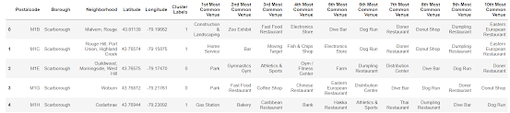](https://lh3.googleusercontent.com/-IYbDm8FdVn8/YCEiAqt0oZI/AAAAAAAALoc/XkVdZq_toz8CKnkgRgByEAKyGNOYaR5ywCLcBGAsYHQ/image.png)

Data Flow:

Data Gathered using Foursquare for Neighborhood and used that data to get common venues using K-means.

**Results:**

Map Of  Scarborough

[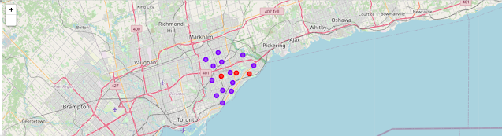](https://lh3.googleusercontent.com/-6mubnL27O2Y/YCEfUSa22YI/AAAAAAAALoA/7t3FSFw9a3Iu3qMkD20T99wpKRveO4o_QCLcBGAsYHQ/image.png)

Scarborough Avg Housing Price

[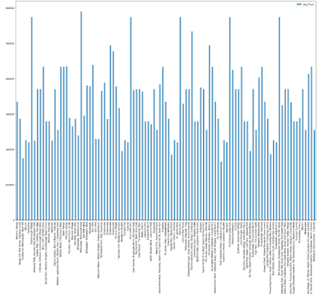](https://lh3.googleusercontent.com/-_iyj1fLlSiQ/YCEf275OCBI/AAAAAAAALoI/44lhY0NlQMkFgNR9PVmfrMdOqtVbPUvYACLcBGAsYHQ/image.png)

Scarborough School Rating:

[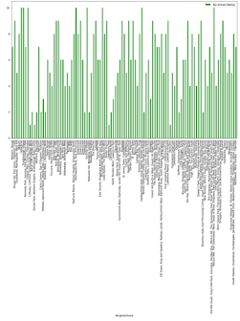](https://lh3.googleusercontent.com/-p_ehFCuNu1E/YCEgJd_vjSI/AAAAAAAALoQ/i21u4pfpuaIhNdDfEHyKWUL3aguFGkuIQCLcBGAsYHQ/image.png)

GitHub Link: https://github.com/vineetsingh065/Coursera_Capstone/blob/master/The%20Battel%20Of%20Neighborhoods%20Week%205.ipynb

**Discussion:**

The major purpose of this project, to will help people to get awareness of the area and neighborhood before moving to a new city, state, country or place for their work or to start a new fresh life.

1. Sorted list of house in terms of housing prices in a ascending or descending order
2. Sorted list of schools in terms of location, fees, rating and reviews

**Conclusion:**

By looking at above bar graphs we can see Scarborough Popular neighborhoods based on Housing Price and School Rating, that will help new migrant people to decide where to live. Using K-means I seperated neighburhood into 5 different clusters with 103 different lattitude and logitude from dataset which have similar neighborhoods around them.

**Libraries Used**

Pandas: For creating dataframes.

Folium: Python visualization library

Scikit Learn: k-means clustering.

JSON: handle JSON files.

XML: To separate data from presentation and XML stores data in plain text format.

Geocoder: Location Data.

Beautiful Soup and Requests: To scrap and library to handle http requests.

Matplotlib: Python Plotting Module.